type() and isinstance() in Python with Examples

As we know, Python does not allow us to declare variables with the datatype mentioned. Python auto allocate the data type to the variable with respect to the data that we put inside the variable. There is a built-in function called type that returns the datatype of the variable.

## Syntax of type function:

**Parameters**: type(object)

* **Object:** This is a mandatory parameter. If this is the only parameter passed to type(), it will return you the parameter type.

|  |
| --- |
| my_list = ["A", "B", "C", "D"] my_tuple = ("A", "B", "C", "D") my_dict = {"A":"a", "B":"b", "C":"c", "D":"d"} my_set = {'A', 'B', 'C', 'D'}  str_list = "Hello World" number = 50 pi_value = 3.14 complex_num = 3j+10  print("The type is : ",type(my_list)) print("The type is : ",type(my_tuple)) print("The type is : ",type(my_dict)) print("The type is : ",type(my_set)) print("The type is : ",type(str_list)) print("The type is : ",type(number)) print("The type is : ",type(pi_value)) print("The type is : ",type(complex_num)) |

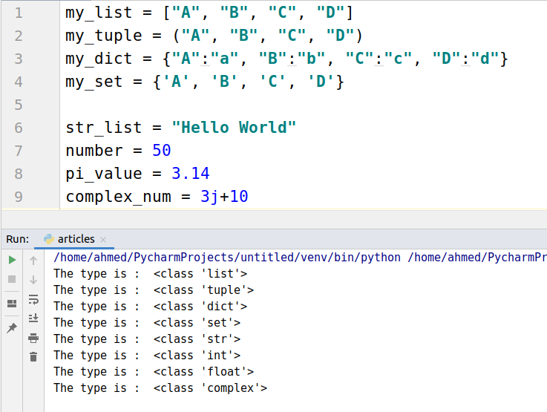

## **Example: Using type() for class object.**

When we call the type function with input as an object of a class, it returns the class type along with the name of the class.

|  |
| --- |
| class car:  color = 'blue'  a = car() print(type(a)) |

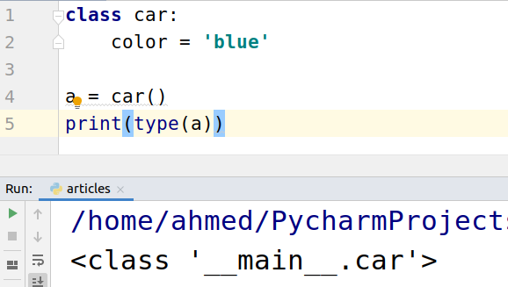

# What is isinstance() in Python?

Python isinstance function is one of the python built-in functions. Python isinstance() takes in two arguments, and it returns true if the first argument is an instance of the class info given as the second argument.

### **isinstance() Integer check Example**

In the example below, we are checking whether 32 is of int type. It returns true as 32 is int.

|  |
| --- |
| num = isinstance(32,int) print("num is an integer:", num) |

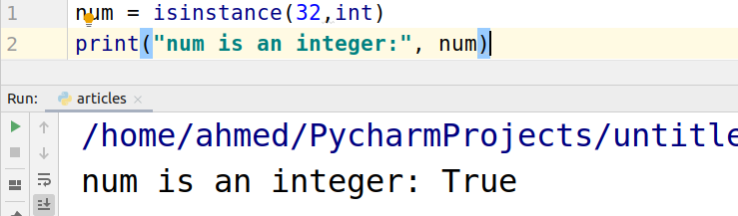

In the example below, we are checking whether 32 is of str type. It returns false as 32 is int.

|  |
| --- |
| num = isinstance(32,str) print("num is an integer:", num) |

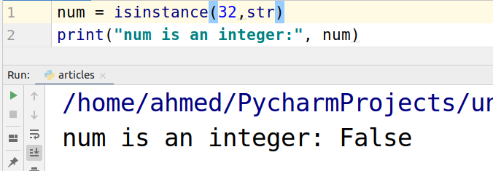

## isinstance() String check Example.

It is same as the above. In the example below, we are checking the weather the given input is a string or not.

|  |
| --- |
| string = isinstance("Hello",str) print(string) |

